**Test Scenarios for mobile.de (mobile view)**

1. Check the 'Menu' functionality

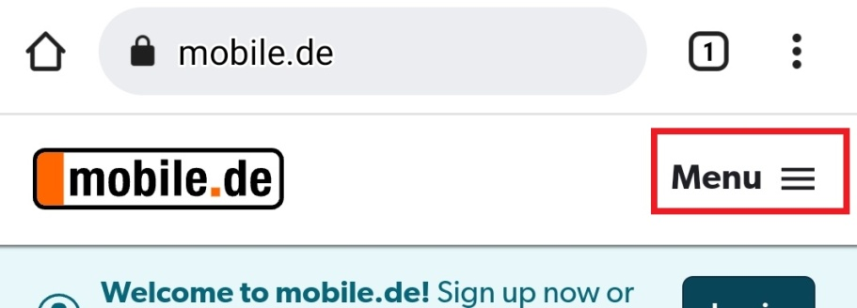

2. Check the 'Login' functionality

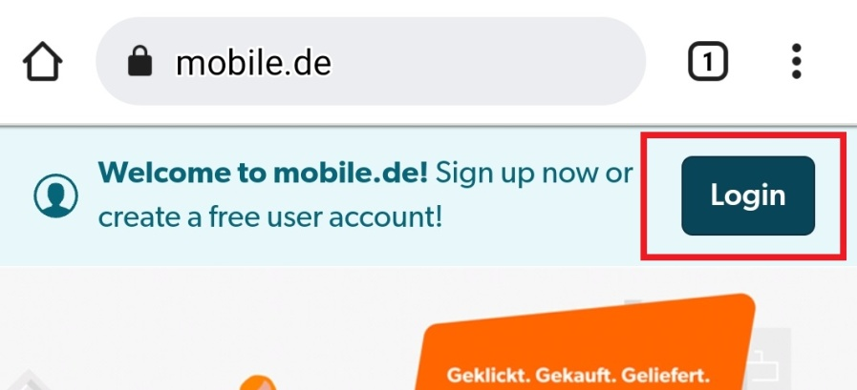

3. Check the filters functionality

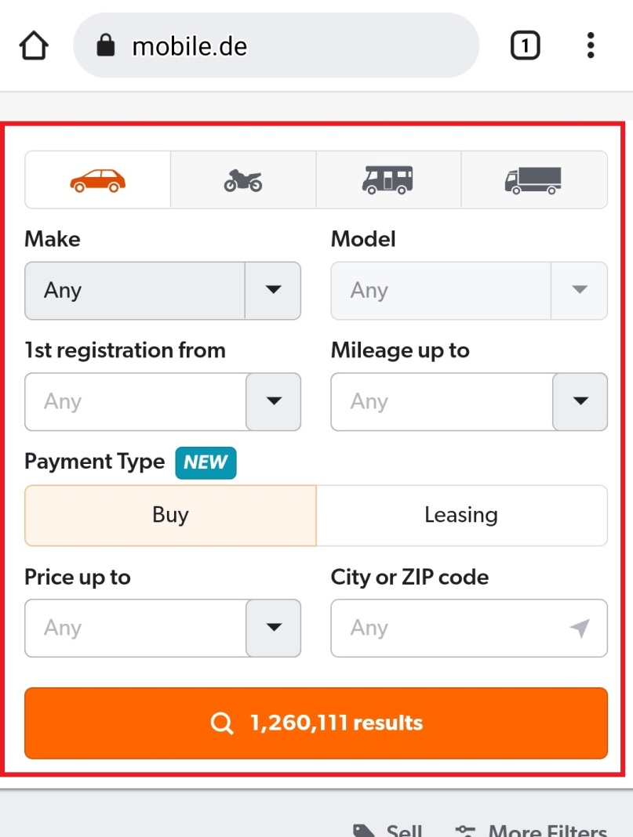

4. Check the 'Sell' functionality

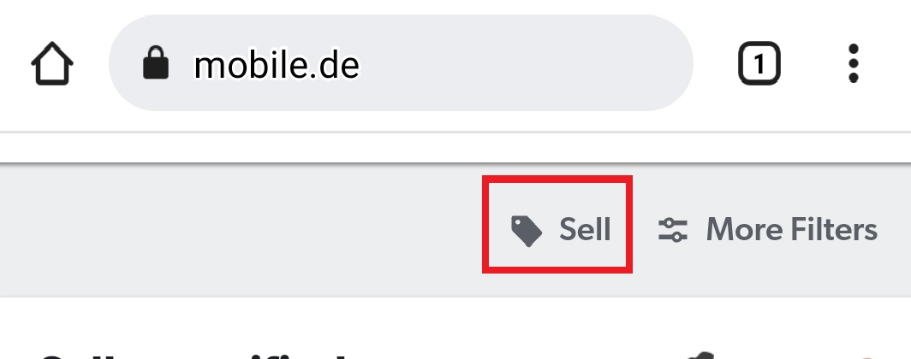

5. Check the 'More Filters' functionality

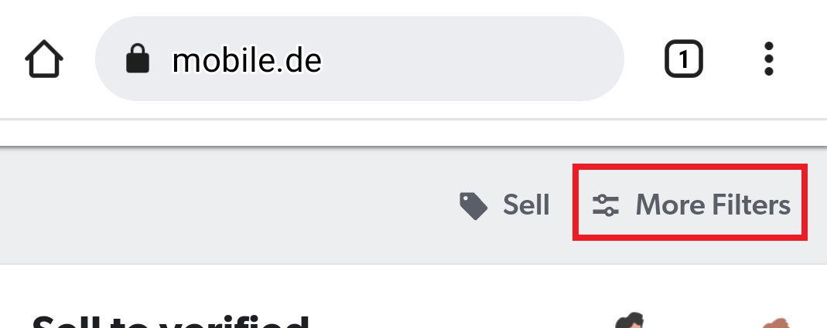

6. Check the mobile.de's ads on page functionality

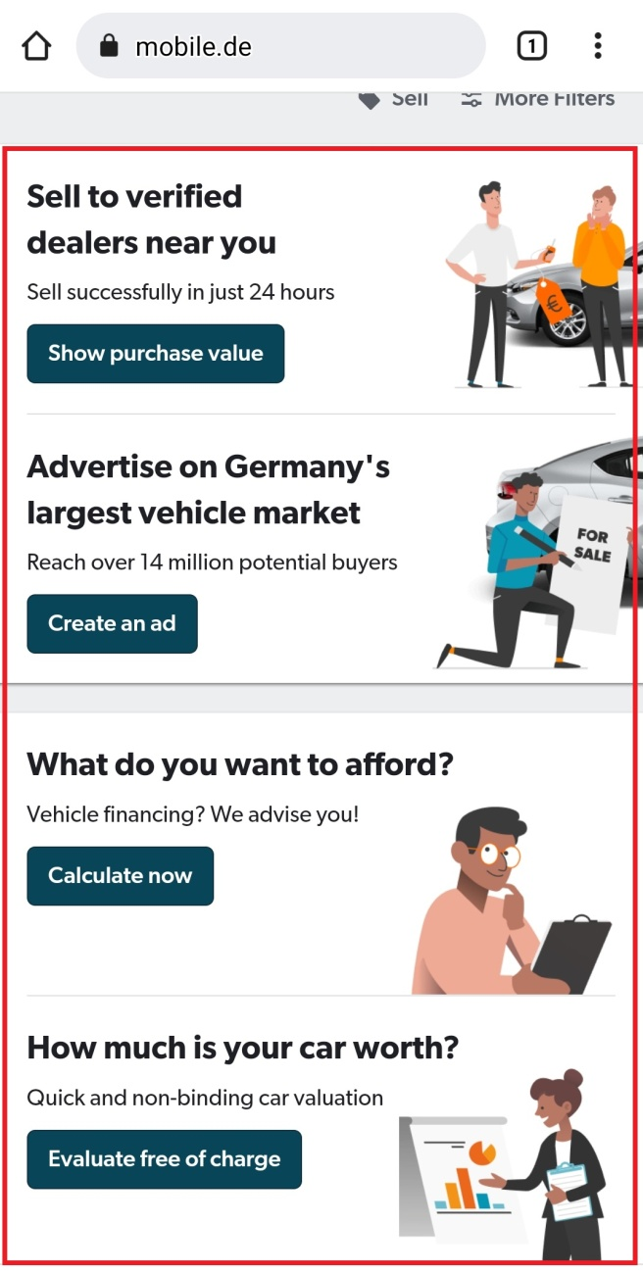

7. Check the 'Company' functionality

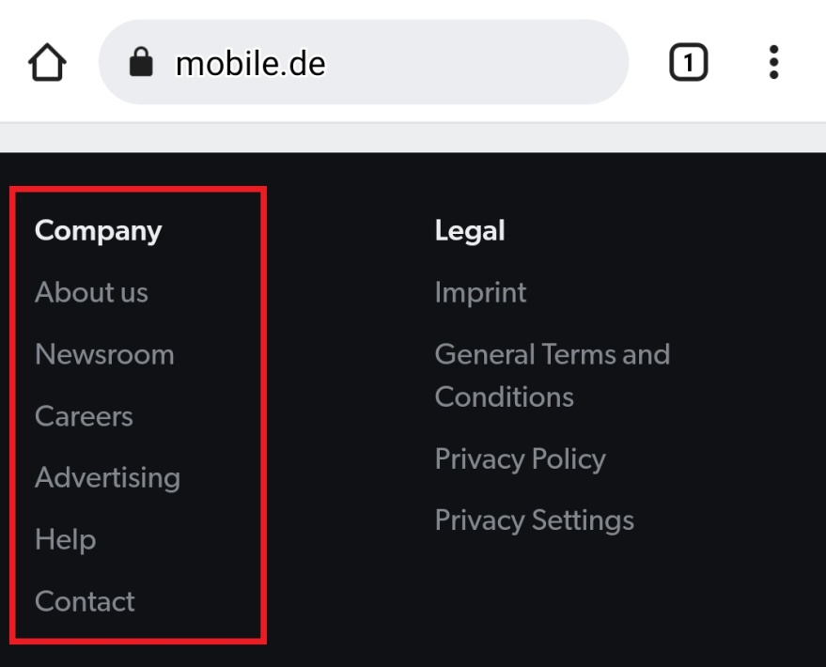

8. Check the 'Legal' functionality

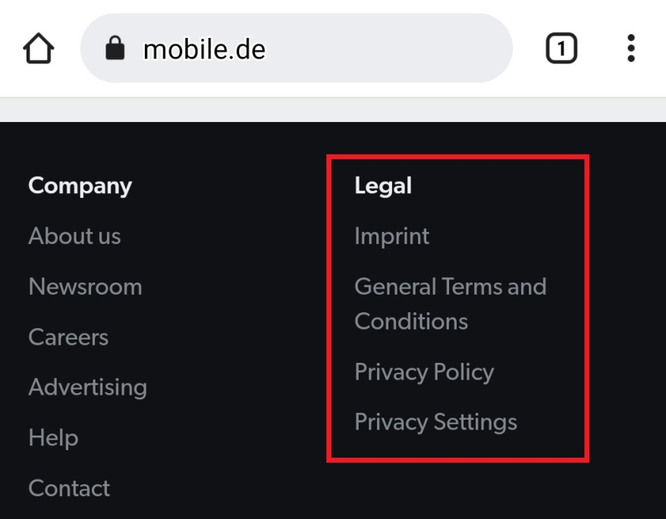

9. Check the 'Dealer' functionality

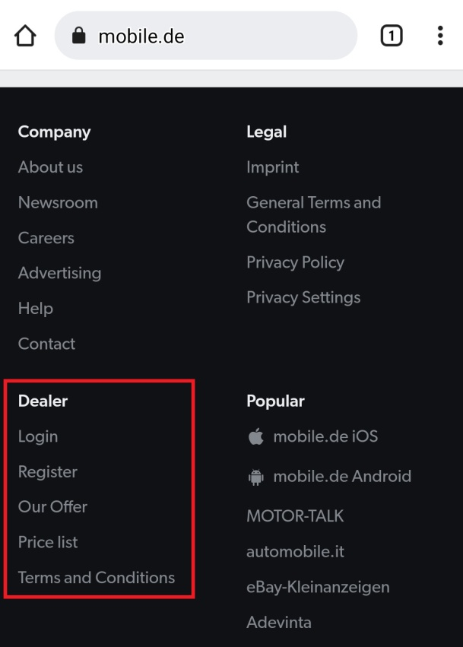

10. Check the 'Popular' functionality

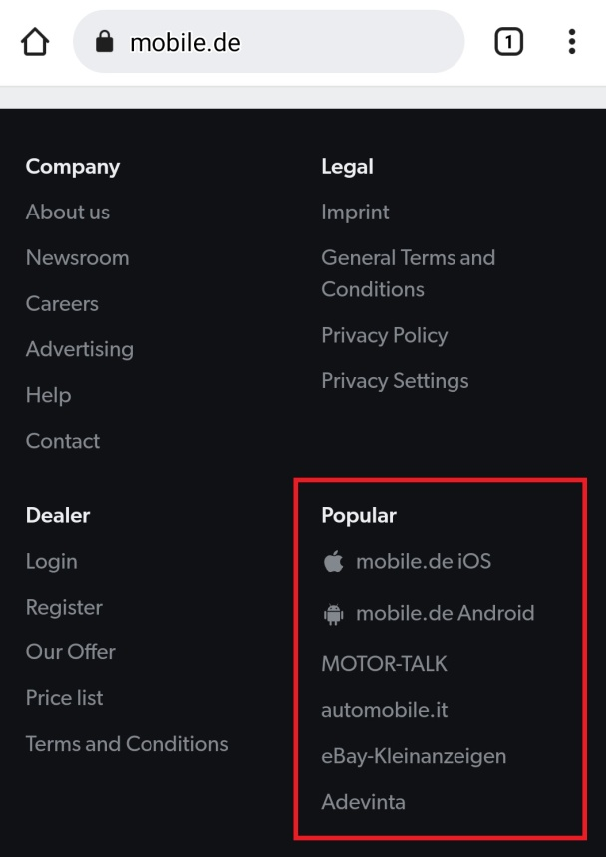

11. Check the links on social networks functionality

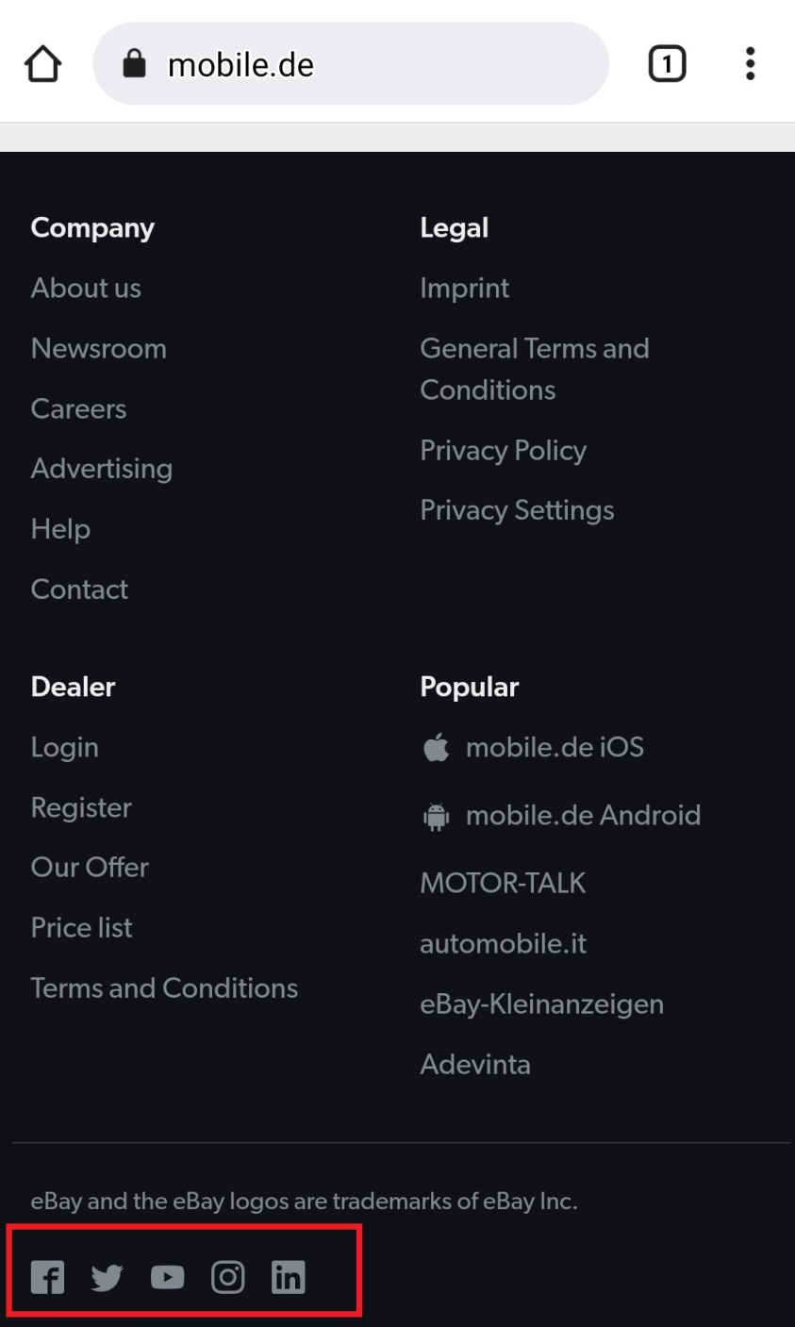

12. Check the language drop down list functionality

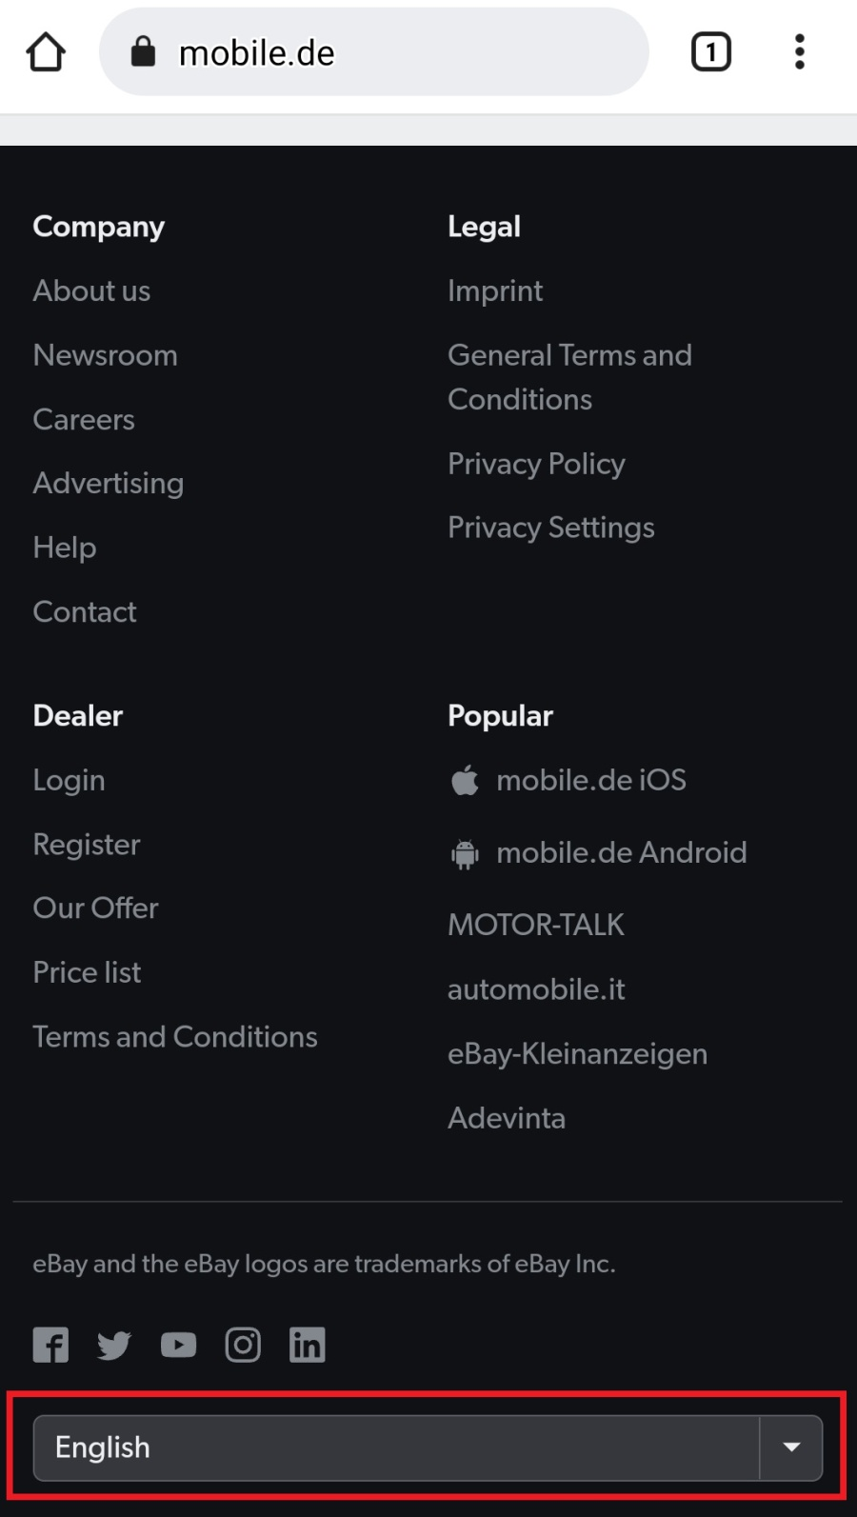

13. Check the mode drop down list functionality

